Eisenhower and His Times: Group Debrief

Name_____________________________________________ Date___________
Directions: Using your individual quote analysis, answer the questions listed below as a group as you make connections between Eisenhower’s character and his conflict resolution skills.
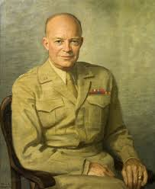
- What character and personality traits did you identify through the quote analysis of Eisenhower?

- Eisenhower was known for resolving many conflicts peacefully. How would the personality and character traits your group identified help Eisenhower resolve conflicts peacefully?

- Although Eisenhower was a great leader, he did not always resolve conflicts well or peacefully. Which of Eisenhower’s personality and character traits might have made conflict resolution more challenging? Why?

- Out of all the quotes on the timeline, which quote best represents Eisenhower’s personality and character? Write the quote below.

